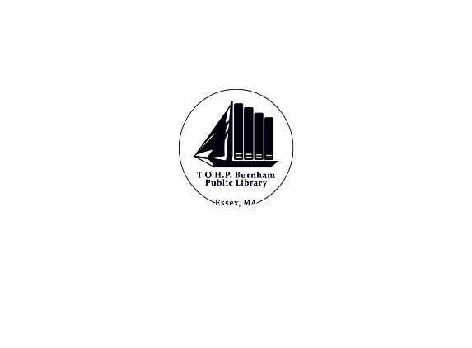
Collection Development Policy

Introduction
The TOHP Burnham Library Trustees and staff members believe that information seeking and learning are indispensable tools for ensuring an educated and responsible citizenry. The TOHP Burnham Library provides materials in a wide variety of formats, technology, programs and staffing, essential to providing 21st century public library service. The community which the TOHP Burnham Library serves focuses on the town of Essex. We also participate in the Merrimack Valley Library Consortium, a group of 36 libraries in neighboring cities and towns covering a wide geographic area with diverse populations.

The TOHP Burnham Library provides equitable service to all library users, regardless of age, race, color, religion, national origin, ability, gender identification, or sexual orientation. The Library Director, acting within the policies established by the Board of Trustees is ultimately responsible for materials selection. The Director can delegate this responsibility to professional librarians or other staff members qualified by reason of education, training, and experience.

Collection Development Policy
The library collects materials in many formats, including print, electronic, recordings and online. New formats are always considered for inclusion; such items must also meet the selection criteria of this policy. Patron usage is the most powerful influence on the library’s collection. Circulation, patron requests and reserves are all closely monitored, triggering the purchase of new items and additional copies of high demand items. Inherent in our collection development philosophy is an appreciation for each library patron; we enthusiastically attempt to provide the library materials they need and request. Personal taste is subjective and librarians guard against letting their personal views and preferences influence their professional duties to form a useful collection for the diverse tastes and opinions of the community. The collection includes items representing a wide range of viewpoints, some of which may be objectionable to others. An item will not necessarily be excluded from the collection because of frank or offensive content. The following standards apply to items considered for acquisition, whether purchased, requested, or donated. An item does not have to meet all of the criteria in order to be acceptable.
The Library Trustees are committed to the principles of intellectual freedom, as expressed in the American Library Association’s Library Bill of Rights and the Freedom to Read Statement.

• Appropriateness of subject and format for intended library users
• Relevance to present and future needs of the community
• Popularity and user demand
• Currency and accuracy of the information
• Representation of trends, subjects, or genres of local or national interest
• Favorable reviews and inclusion in reputable resources, such as bibliographies, publishers' catalogs, and professional or trade journals
• Comparison to the strengths and weaknesses of the existing collection
• Consideration of the work as a whole, rather than on the basis of specific sections
• Comparison to the local history collection
• Durability and sustainability of format for library use
• Space requirements and processing requirements
• Availability of materials through other area libraries or via electronic resources
The Board is committed to the principles of intellectual freedom, as expressed in the American Library Association’s Library Bill of Rights and the Freedom to Read Statement.
Requests for the purchase of library materials are given careful consideration, and these requested items may be added to the collection providing they meet the same criteria as all other materials purchased by the library.
Donations
The TOHP Burnham Library recognizes the potential value that donations can add to the Library's collections. Donations to the Library can be in the form of money or actual materials. Donations to the Library are evaluated according to the same selection criteria as purchased Library materials. Once an item has been donated it is the property of the Library and is subject to the same processing, usage and disposal criteria as all Library materials.
Collection Management
Without a well-managed collection, the Library’s usefulness declines. Collection management ensures that materials are appropriate to the library's objectives, easy to locate, and attractive to users. The Library's credibility is enhanced when the books and other materials are found by patrons to be up to date and relevant, and when the Library's bibliographic records, such as the online catalog, accurately reflect its holdings. Collection management accomplishes multiple purposes in analysis, inventory control and deselection. CREW, and its MUSTIE guidelines, is the primary criteria used to assist selectors in weeding. (https://www.tsl.texas.gov/ld/pubs/crew/index.html)

DONATION RECEIPT

Date

Item_____________________________________________________________donated to
TOHP Burnham Library 30 Martin St Essex, MA 01929

Hardcover Paperback Media
other

Collection Management
Without a well-managed collection, the Library’s usefulness declines. Collection management ensures that materials are appropriate to the library's objectives, easy to locate, and attractive to users. The Library's credibility is enhanced when the books and other materials are found by patrons to be up to date and relevant, and when the Library's bibliographic records, such as the online catalog, accurately reflect its holdings. Collection management accomplishes multiple purposes in analysis, inventory control and deselection. CREW, and its MUSTIE guidelines, is the primary criteria used to assist selectors in weeding. (https://www.tsl.texas.gov/ld/pubs/crew/index.html)

Updated 6/2022
Adopted 4/2022

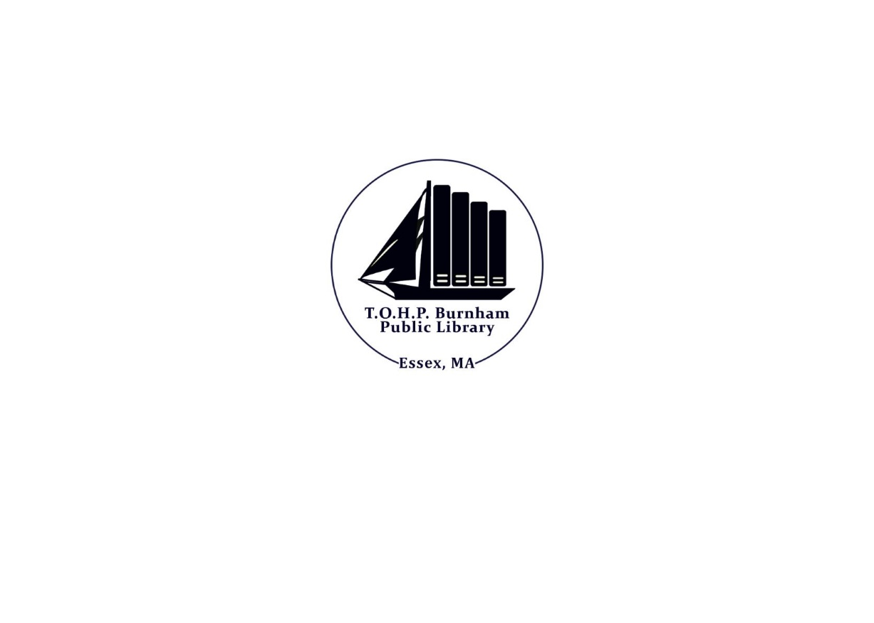

Reconsideration of Library Materials

Library patrons who reside in Essex with a valid library card in good standing may request reconsideration of library materials. The Trustees establish this procedure for reconsideration to address concerns about Library materials.
• The patron will be directed to the Library Director, who will explain the materials selection policy to the patron.
A copy of the policy may be given to the patron if requested.
If the patron wishes, he or she may fill out and submit a Request for Reconsideration of Library Materials Form.
• The completed form will be reviewed by the Library Director.
The material will be evaluated to ascertain that the selection criteria outlined in this policy were applied in the selection of the material.
The Library Director shall deliver a written response to the patron within 14 days of the date that the Reconsideration Form was submitted.
If the patron is not satisfied with the decision, he or she may appeal in writing to the Library Director, who then convenes a Reconsideration Committee.
The committee will consist of a Library Trustee, a member of the library staff, and members of the community selected jointly by the Trustees and the Library Director.
As the material is being reviewed, the Reconsideration Committee employs the selection criteria outlined in this document, as well as reviews from professional journals, and objection(s) of the patron.
The material will be reviewed in full. Library materials will not be removed from the collection during the review process.
The committee will recommend an action to the Library Director within 30 days of the formation of committee.
The Library Director will inform the patron in writing of the final decision. Results of the Reconsideration will be retained on file.

Updated 6/2022
Adopted 4/2022

Request for Reconsideration Form

Title: _________________________________________________________________________

Author(s): _____________________________________________________________________

Publisher: ____________________________________ Copyright date: ________________

Format (i.e. book, DVD, etc.): __________________________________________________

What is your objection to the material? Feel free to use the back of this form

Have you read/viewed/listened to the entire work?

Which parts (please specify page numbers, chapters, scenes, song titles, etc.)?

What action are you requesting the reviewing Committee to consider?

Name: ______________________________________________________________________
Address: ______________________________________________________________
Home Phone: _____________________ Work Phone: _________________________
Email_____________________________________________________________

Signature: ___________________________________ Date: _____________________

Updated 6/2022
Adopted 4/2022

